 Sample Todo Project (Mobile/Server) solution (Project Id)

Technical Design Document
```

Purpose

Technical structure for Sample Todo Project

This document is intended only to describe the technical structure of the sample todo project as well as explain the patterns used accorss the project as well as third party libraries and usages

The full project anatomy of each project in the solution

The tools used to write the code should be also illustrated in this poject

Introduction

The Problem

The problem is building a sample Todo List saving app that supports Syncing between local storage and Cloud/server App.

The Solution

The Mobile app is designed with Xamarin Forms

The Clould/Server App is an azure mobile app designed entirely in a .net backend project.

Unit Testing and UI Testing Measures

Both backend and mobile app has some level of Unit testing including a UI Test project that employ Xamarin UI Testing as well as BDD Methodology using Specflow to write natural language test cases using Gherkin and cucumber, even thought that there might only be one test case, but a whole architecture for page object model patter is implemented to some level to be continued on the rest of the tests

the Tools

The main tool used to develop is Visual studio 2017
          - Xamarin Features is chosen during installations
          - Android SDK
          - Mac Build Agent with Xamarin installed as well as Xcode Development Environment
          - Windows Azure for Services and database hosting

Project Anatomy for BAckend and Mobile App

Backend

The folder structure

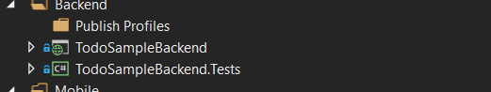

The backend project is saved in the Backend Solution Folder

The first folder is the publish profiles forlder that contains the publish profile with the credentials to publish on Azure

The second is the backend project itself it is a multi layer folder structured backend application, and it is not an Assembly based structure, meaning that all the layers are in the same assembly

The third is the backend tests project which tests the layers of the .net backend using NUNIT and moq

TodoSampleBacken Project

The Layers are as Follow
          - Data

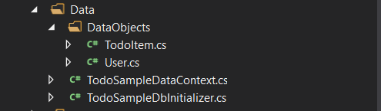

DataObjects Contains all the todo POCO Model

The Code First DB Context

The Database Initializer
          - Migrations

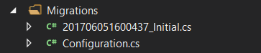

Contains the migrations and migration settings
          - Repository



Contains the repsitories for the project
          - Business

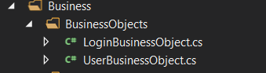

Contains the businss services and the business objects that are mapped to database objects using auto mapper
          - Controllers

The Service Layer where the APIs exist for the syncing and user Authentication authorization logic Designed as an SOA Architecture.

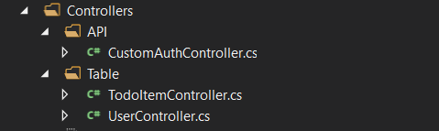
          - Models

The Models contain the SOA Object also mapped to the Business objects using automapper

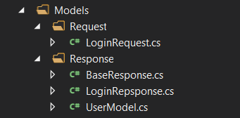
          - Interfaces

This Layer contains the interfaces used across all layers

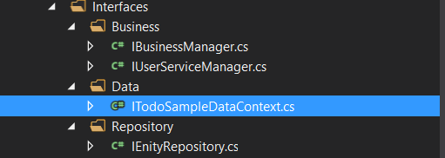
          - AppAutoFac.cs

The Dependency injection instance to be used when needed to manualy resolve dependencies using autofac
          - AutomapperConfigurator.cs

The Automapper Configurations
          - TodoSampleBackendAppModule.cs

Contains the whole Dependency injection configuration for the whole project
          - Bootstrapper.cs

The main initializer of the app life cycle Registering the dependencies and mappings

TodoSampleBackend.Tests

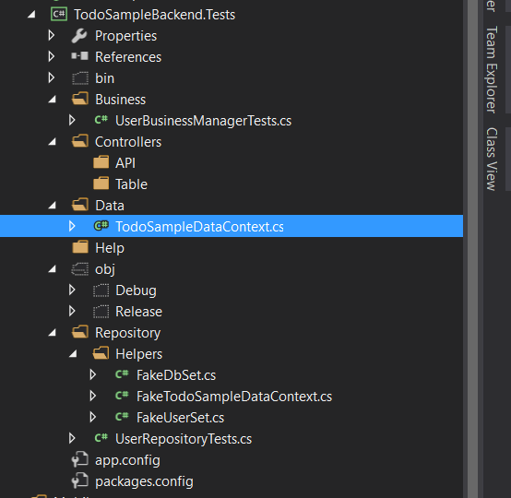

Contains the equivelent Layers test according to structure of the backend

tHE mOBILE aPP

The Mobile app is a multi-assembly structured app, Done in multi portable libraries and two platform projects targeting iOS and Android, as well as the UI test project that tests it.

They are all under the mobile folder

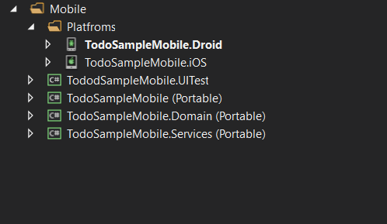

The Projects are structured as following
          - TodoSampleMobile.Services

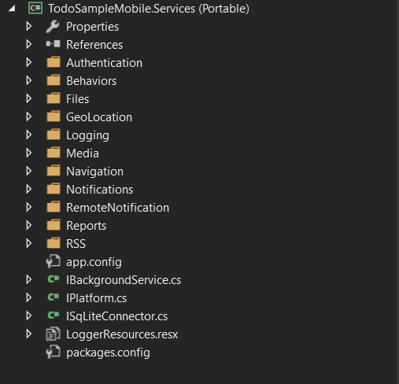

Authentiation is the folder containing the authentication for local cashing and platform specific authentication features interfaces

Behaviors Folder contains the common Xaml behaviors as they might be used across the app, such as Event to command behaviour

A list of helpers is also included for a file helper, and geolocation helper, application logging under logging folder, Notificaitons and local notifications
          - TodoSampleMobile.Domain

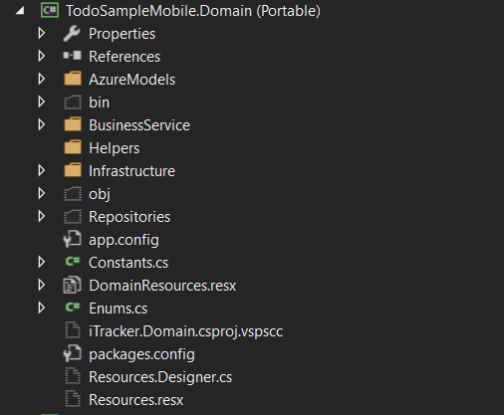

Contains the domain business objects as well as the user services and Syn Service as well as constants and enums

The infrastrucure contains the main sync services as well as the azure initializer as well as the generic repository that queries the table from local storage

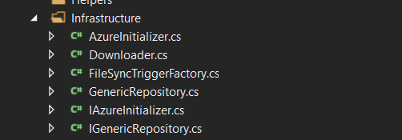

The bussines Service contains the services used to manipulate the data get the sql storage data and so on.

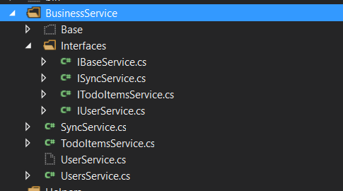
          - TodoSampleMobile

The invertion of control to navigate and communicate using viewmodels instead of views and this is done be registering the views and view models against each other in the bootstrapper

The Main Presentation XAML Portable containing the MVVM Structure and the whole views and controls

Converter Folder contains a set of XAML Converters to be used across the project

Custom views for custom controls when needed

Helper folder contains the Helper for the XAML Project

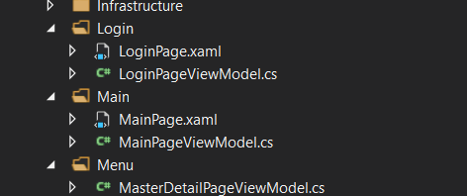

The Login folder contains the view and view models for the login and the same for the Main page and menue

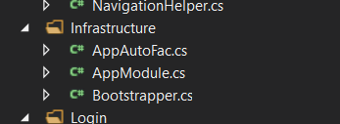

The infrastructure Contains the Autofac Dependency injection as well as the bootstrapper to get things started and handles the life cycle of the app and intiates it.

